Event-Driven Architecture
# Source: AI Source: Provided by: [Data Path: Persons Table -> ID Column: 1, Name_En Column: Motasem Essam] -> From: [ChatGPT] on [1/23/2026]
Event-Driven Architecture (EDA) organizes a system around events—signals that something has happened. Components react to events asynchronously, enabling real-time processing and loose coupling.
👉 Think of it like a notification system: when an event occurs, any service interested in it can respond.

🔑 Key Points
# Source: AI Source: Provided by: [Data Path: Persons Table -> ID Column: 1, Name_En Column: Motasem Essam] -> From: [ChatGPT] on [1/23/2026]
- Components communicate by emitting and listening to events
- Supports asynchronous processing
- Loosely coupled: producers of events don’t need to know consumers

🧱 Structure Example
# Source: AI Source: Provided by: [Data Path: Persons Table -> ID Column: 1, Name_En Column: Motasem Essam] -> From: [ChatGPT] on [1/23/2026]
UserCreatedEvent → EmailService → NotificationService → AnalyticsService
- UserCreatedEvent → Triggered when a user signs up
- EmailService → Sends welcome emails
- NotificationService → Sends in-app notifications
- AnalyticsService → Updates user metrics

❌ Common Problems (Bad Practice)
# Source: AI Source: Provided by: [Data Path: Persons Table -> ID Column: 1, Name_En Column: Motasem Essam] -> From: [ChatGPT] on [1/23/2026]
- Components directly calling each other instead of using events
- No central event broker for coordination
- Event ordering not considered, leading to inconsistent state
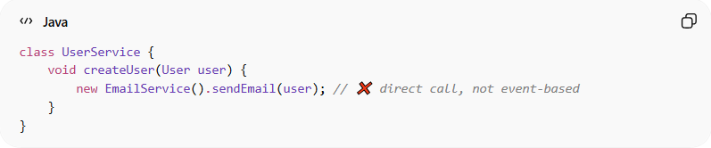
class UserService {
void createUser(User user) {
new EmailService().sendEmail(user); // ❌ direct call, not event-based
}
}

✅ Benefits (Good Practice)
# Source: AI Source: Provided by: [Data Path: Persons Table -> ID Column: 1, Name_En Column: Motasem Essam] -> From: [ChatGPT] on [1/23/2026]
- Real-time and responsive system
- Loosely coupled components → easier to maintain and scale
- Multiple services can react to the same event independently
- Supports asynchronous workflows
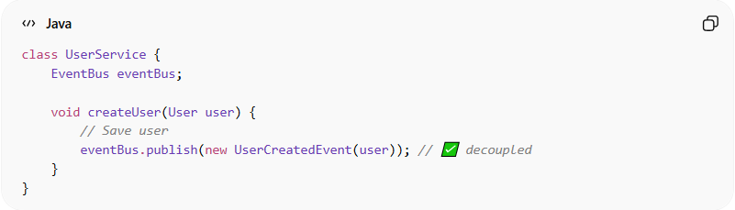
class UserService {
EventBus eventBus;

void createUser(User user) {
// Save user
eventBus.publish(new UserCreatedEvent(user)); // ✅ decoupled
}
}

⚡ When to Use
# Source: AI Source: Provided by: [Data Path: Persons Table -> ID Column: 1, Name_En Column: Motasem Essam] -> From: [ChatGPT] on [1/23/2026]
- Real-time applications (chat, notifications, IoT)
- Systems needing loose coupling and flexibility
- Applications with multiple independent consumers reacting to the same event

